Course Name – Computer Engineering Time – 10.00 to 11.00 am Semester –IV (CO4G) Max Marks - 25

Subject- Object Oriented Programming (17432) Date- 9/3/2017

____________________________________________________________________________________________

**Q.1) Solve any Three of the following (9 marks)**

1. What is a pointer? Write down the general syntax of its declaration.

2. Write a program to find length of a string using pointer to the string

3. What is inheritance? Why inheritance used in C+ +?

4. Give types of inheritance for following diagram

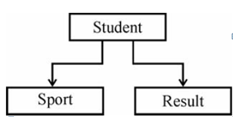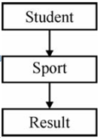

**Q.2) Solve any Two of the following (8 marks)**

1. Explain different visibility modes used in inheritance.

2. Explain with example the hierarchical inheritance.

3. Describe multiple inheritance with suitable example.

**Q.3) Solve any Two of the following. (8 marks)**

1.Write a program to copy the contents of one string to another string using pointer to string.

2. What is virtual base class ? Explain with example.

3. Identify the type of inheritance and implement it by writing a program for the following Figure No. 2. Assume suitable member functions.

